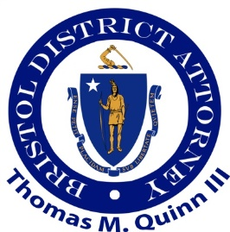

A Bristol County Celebration of Seniors
Whites of Westport: Friday, June 14th, 2024 from 9 a.m. to 12 p.m.

Registration Form for Vendor Tables
Name of Organization:
Address:

Name of Contact: ___________________________________________________
Contact Information Email: ___________________________________________
Contact Information Phone:
Non-Profit Table $50 o For Profit Table $75 o Federal, state or municipal agency (no charge) o
Will you need an electrical outlet? Yes o No o Do you have an 8 foot table cloth? o Yes
Payment must be received by May 24th, 2024, for participation in this event
Please make checks payable to Coastline Elderly Services, 863 Belleville Avenue, New Bedford, MA 02745. Reference: Celebration of Seniors 2024

For registration or questions, please contact Natacha Salemme at
NSalemme@CoastlineNB.org or 508-742-9113.

